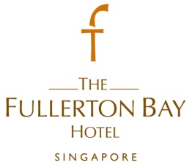
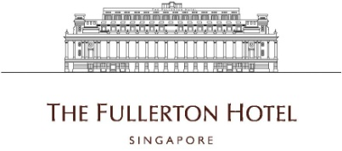

Assistant Marketing Communications Manager / Marketing Communications Manager
- Assist the Director of Marketing Communications in development and implementation of marketing communication strategies
- Coordinate communications projects with vendors and contractors for the development and production of event promotional materials, web site production and other collaterals.
- Provide writing and editing support for all communication including all promotional materials and website content
- Review and edit existing promotional materials for marketing effectiveness, cross-selling implications and adherence to brand guidelines.

Requirements :
- Candidate must possess at least a Diploma, Advanced/Higher/Graduate Diploma, Bachelor's Degree, Post Graduate Diploma, Professional Degree, Marketing, Advertising/Media, Linguistics/Languages, Mass Communications or equivalent.
- At least 3 year(s) of working experience in the related field is required for this position.
- Ability to effectively work under tight deadlines and manage projects independently
- Resourcefulness in solving problems
- Excellent people skills and an upbeat and enthusiastic attitude
- Preferably Junior Executives specializing in Public Relations/Communications or equivalent.

To apply for the above positions, please send your full resume to careers@fullertonhotel.com.

