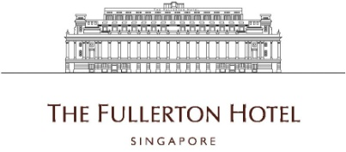

Chef de Partie Cook (Cold / Local / Pastry / Western / Local)
- Participate in the food preparation in accordance with accepted standards of quality
- Training and development of new and existing employees
- Ensure the overall cleanliness and the health and safety aspects of the kitchen are maintained at all times
- Responsible for proper storage, labelling and use of all food supplies to prevent unnecessary spoilage and to maintain cost control
- Work closely with the Executive Chef to ensure kitchen is running smoothly and efficiently
- Optimize food quality and guest satisfaction
- Assist the Executive Chef with Menu planning, inventory control, scheduling, ordering of kitchen supplies.

Requirements :
- Ability to establish priorities and work independently as well as part of a team
- Ability to handle and resolve recurring problems and customer complaints in a professional and tactful manner
- Applicants must be willing to work shift duties including weekends and public holidays.

To apply for the above positions, please send your full resume to careers@fullertonhotel.com.

