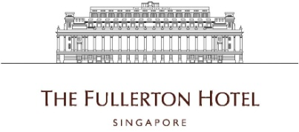

Commis Cook (Cold / Local / Pastry / Western / Local)
- Sets up station according to restaurant guidelines.
- Prepares all food items as directed in a sanitary and timely manner.
- Follows recipes, portion controls, and presentation specifications as set by the Hotel.
- Restocks all items as needed throughout shift.
- Cleans and maintains station in practicing good safety, sanitation, organizational skills.
- Prepare and accommodate all daily food products and guest requests.
- Has understanding and knowledge to properly use and maintain all equipment in station

Requirements :
- Applicants must be willing to work shift duties including weekends and public holidays.
- With or without experience are welcomed to apply.
- Able to understand, speak and write simple English.

To apply for the above positions, please send your full resume to careers@fullertonhotel.com.

