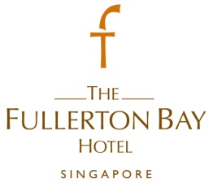
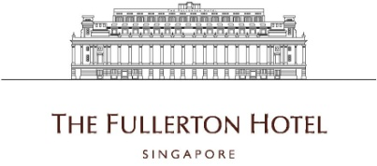

Facilities Manager
- Responsible for day-to-day operations of the establishment
- Manage current properties e.g. arrange for maintenance & repair, security & etc
- Call tender/quotation for contract works, such as security, pest control, carpark system, etc
- Manage, review, evaluate and approve Costing/Quotes for building works & facilities contract services
- Prepare tender documents and specifications
- Submit evaluation and recommendation for approval
- Supervises and manages term contractors in fulfilling their contract’s obligation Liaise and check on contractors’ performances
- Carry out planning, implementing and monitoring of maintenance schedules.
- Ensure all building services under his/her care are regularly maintain and in good operating condition.
- Establish good working relationships with tenants to develop trust and confidence
- Coordinate and liaise with external agencies on new initiatives, major repairs and maintenance works
- Liaise with client and tenants on all maintenance and projects matters
- Attend to all complaints, feedback and service requests from Client/Tenant/Members of Public
- Involved in projects from conceptualization, schematic design, detail design, tender documentation review to construction
- Knowledgeable about authorities approval and to work with consultants to secure all necessary planning and technical clearances Lead, manage and coordinate closely with consultants, contractors and site team to deliver results
- Co-ordinate well with HQ (at HK) design department to align on design for group standard
- Assist in-house projects under CAPEX projects as and when require
Requirements :
- Diploma in Facilities Management / Building / Mechanical / Electrical Engineering
- 5 years’ of relevant working experience
- Good communication and interpersonal skills
- Able to work independently under tight deadline
- Familiar with Facility Management
- Good understanding of design, building regulations and project implementation process

To apply for the above positions, please send your full resume to careers@fullertonhotel.com.

